Dataset investigation

NASA’s FIRMS
NASA has multiple sensors with available data about wildfires across the globe. The sensors available are MODIS, VIIRS and LANDSAT (in specific regions). The data available from NASA is available in 24h, 48h and One week. However, to access archival data a special request must be made and approved by NASA. This may be a problem when trying to access data around a specific wildfire event. Additionally, the sensors from the satellites only pick up on actual fires and other anomalies so before and after data cannot be found from this source, this dataset would be better suited for detection than prediction.
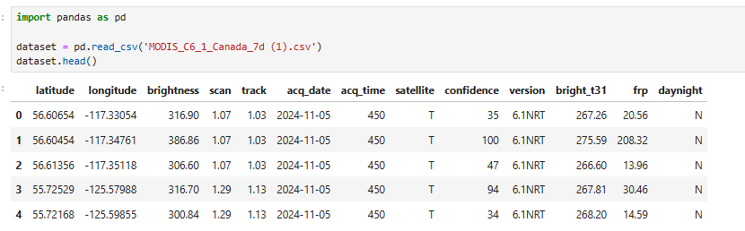
The dataset using the MODIS sensor includes of the coordinates, date and time, scan and track (which are the width and heigh of the scan in degrees), fire radiative power, the label of the satellite and two brightness indicators. Brightness is the measure of the temperature in Kelvin of the area being observed, however, bright_t31 is much more sensitive and is specifically used to detect thermal anomalies, a high value of bright_t31 is a good indication that a fire is present.
If I were to use this dataset the target variable would be confidence, confidence is a score between 0-100 that a fire is actually present.
The FIRMS data is not that suitable for prediction when compared to detection however, this is because it does not include any data that does not have a thermal anomaly in it. This would make it quite difficult to predict as the model will not be able to learn any patterns in data that lead to a fire. Additionally, the sensors do not have any data to do with the vegetation, humidity or wind which all can be used to predict the likelihood of a fire, the dataset primarily focuses on current detections such as the radiative power and brightness. This lack of environmental context means that to perform a prediction more data would be needed to have an accurate prediction.

Forest Fires in North-east Portugal dataset
Link: https://archive.ics.uci.edu/dataset/162/forest+fires
This dataset is designed to predict the area burned by forest fires in Montesinho natural park in Portugal.
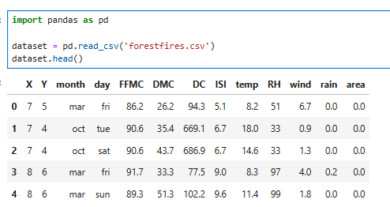
It includes a multitude of features that were not present in the FIRMS data such as FFMC (Fine Fuel Moisture Code), DMC (Duff Moisture Code), DC (Drought Code), ISI (Initial Spread Index), RH (Relative Humidity) as well as the wind and rain. These features in the data are much more applicable for prediction problems.
However, this dataset does not have a high spatial resolution due to the coordinate system used by the creators of the dataset unlike FIRMS which uses precise global coordinates. This system sections off areas of the natural park into coordinates which are not very precise. Additionally, the dataset does not include a suitable target variable for prediction of a fire. The target variable for this dataset is area burned not confidence which is a prediction task, however not what the project is trying to accomplish.
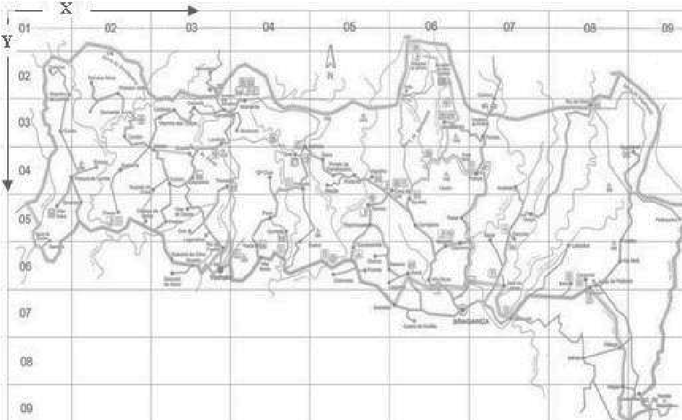

Wildfire Prediction Dataset (Satellite Images) in Canada
Link: https://www.kaggle.com/datasets/abdelghaniaaba/wildfire-prediction-dataset

This dataset contains satellite images (350x350px) in 2 classes:
- Wildfire: 22710 images
- No wildfire: 20140 images
This dataset is available on Kaggle and consists of only images which have been sourced from the Canadian open government portal. This dataset could be used to train predictive models to detect the probability of a wildfire. However, it does not feature before and after images of fires themselves instead simply just images of Canada with or without a fire. This means a model could learn the difference between a fire and no fire and attempt to distinguish patterns between the two images. The dataset does include the vegetation and topography of the land as it is images from the satellites rather than raw data
However, the lack of before and after data may lend this dataset more to wildfire detection rather than prediction. Additionally, the dataset does not contain numerical data only images. This means that some factors such as windspeed and direction may not be taken into account as that cannot be seen from looking at an image alone.

Google Earth Engine Landsat
Link: https://developers.google.com/earth-engine/datasets/catalog/landsat
Google Earth Engine’s Landsat images may be of use as there is a lot of free to use data which is designed for many different purposes. The data includes data from different spectral bands, LANDSAT 8 and 9 include thermal imaging which will be required for fire prediction, it also includes data about cloud coverage and the position of the sun which could be factors in the creation of a wildfire. However, the nature of the data is a lot more complicated than the other datasets and the preprocessing of the data must be much more substantial as to remove unnecessary features that are not required for wildfire predictions. The data has global coverage instead of a specific region which means that data extracted from Landsat would have to be filtered to only have data taken from a specific region.
Therefore, the dataset would be of use to predict wildfires as long as the data collected from Google Earth Engine contains data from areas that have had recent wildfires, it would just need to be specialized to the task of wildfire prediction.

